**Module 1[Software]**

**Assignment**

B1.What is software?

Ans: Software is a set of instructions, data or programs used to operate computers and execute specific tasks. It is the opposite of hardware, which describes the physical aspects of a computer. Software is a generic term used to refer to applications, [scripts](https://www.techtarget.com/whatis/definition/script) and programs that run on a device. It can be thought of as the variable part of a computer, while hardware is the invariable part.

B2.Types of software?

Ans: **The 3 types of computer software**

* System software. ...
* Utility software. ...
* Application software.

B3.What is Software Development Methodology?

Ans: A software development methodology is **a process by which developers design, implement and test new computer programs**. Following a methodology benefits developers because these processes lay out a structured sequence of steps that guide professionals through each stage of development.

B4.What is Design Pattern?

Ans: Design patterns represent the best practices used by experienced object-oriented software developers. Design patterns are solutions to general problems that software developers faced during software development. These solutions were obtained by trial and error by numerous software developers over quite a substantial period of time.

**Intermediate**

1. What is the difference between Application software and system software?

Ans:

|  |  |
| --- | --- |
| **Difference Between System Software and Application Software** | |
|  |  |
| System Software | Application Software |
|  |  |
| This acts as an interface between the system and the applications | This is designed directly from the user perspective |
| It is the platform that allows the various application software to run on the system | These are independent applications which can be download and installed in the system |
| System Software is generally developed in low-level languages. This is so that the interaction between the software and hardware can be simplified and made more compatible | Each application has a specific purpose and thus is developed with high-level languages so that the purpose can be fulfilled |
| Is working is more automated. Once a system is turned on, the system software starts working | User action is required to start application software. These applications can only be work when the user commands the system to do so |
| These are responsible for the working of the system | They have minimum involvement in the processing and functioning of the computer device |
| The system software are installed at the time of installing the operating system. A computer device cannot work without its presence | The application software can be installed as and when the user requires them |
| It is an independent software. Once this is installed the computer will work | This is a dependent software. Applications can only be downloaded when the operating system is installed |
| Since a device cannot work without a system software, the user has to have it installed in their devices | These are designed to be user interactive, thus the application software can be removed as and when required by the user |
| Example for System Software includes Android, Mac Operating system, MS Windows, etc. | Examples of Application Software includes Word Processor, games, media player, etc. |

2.Explain the SDLC Each face process?

## Ans: SDLC Phases

While every SDLC is unique, all life cycles go through similar steps. Let's take a close look at every typical phase of an average software development life cycle.

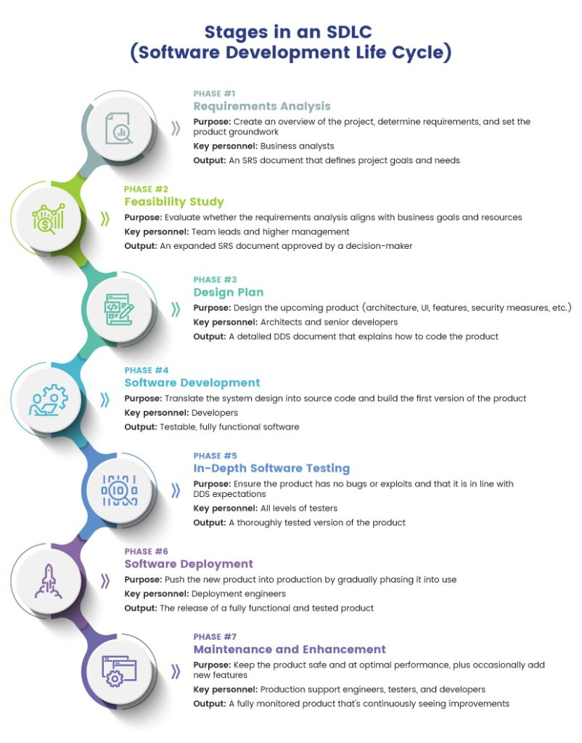

3.Create the DFD of Login Process of facebook.com?

Ans: Here's a high-level description of the login process of Facebook.com:

DFD:

1. The user initiates the login process by entering their email or phone number and password on the Facebook login page.
2. Facebook's servers receive the login credentials and verify their authenticity by comparing them to the user's account information stored in their database.
3. If the credentials are correct, Facebook generates an authentication token and sends it back to the user's browser.
4. The user's browser stores the authentication token in a cookie or a browser storage mechanism.
5. The browser sends the authentication token along with any subsequent requests to Facebook's servers, allowing the user to access their Facebook account.

Flowchart:

1. The user navigates to the Facebook login page and enters their email or phone number and password.
2. Facebook's servers receive the login credentials and verify their authenticity.
3. If the credentials are correct, Facebook generates an authentication token.
4. Facebook sends the authentication token back to the user's browser.
5. The user's browser stores the authentication token.

The user is redirected to their Facebook news feed, and the authentication token is sent along with any subsequent requests to Facebook's servers.

Advance

1.Create the Project Documentation of Assignment Project With all diagrams?

1. Ans: Introduction

* Purpose and Scope of the Project
* Objectives
* Project Description
* Assumptions and Constraints
* Technologies and Tools used

1. Project Requirements

* Functional Requirements
* Non-Functional Requirements
* Use cases

1. Design

* System Architecture Diagram
* Sequence Diagrams
* Class Diagrams
* ER Diagrams
* UI Mockups

1. Implementation

* Coding Standards
* Code Walkthrough
* Unit Testing

1. Testing

* Test Plan
* Test Cases and Results

1. Maintenance and Support

* Maintenance Plan
* System Administration Guide

1. Conclusion

* Lessons Learned
* Future Enhancements